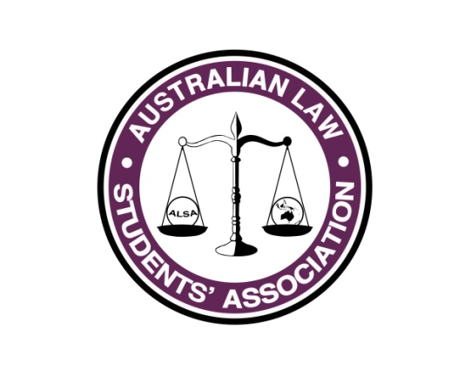
Conference 2017 Report
Name: Max Stenstrom
Position: 2017 Conference Convenor
E-mail: conference2017@alsa.net.au

What has happened so far...
- Team
  - Publicised organising committee positions
  - Received and assessed over 100 applications
  - Established ten person organising committee
- Accommodation
  - Researched and reached out to more than a dozen accommodation providers
  - Inspected six accommodation options and received quotes from five
  - In consultation with my team, the President and VP (finance) three accommodation contracts were drawn up, reviewed and signed off
- Venues
  - High Court of Australia confirmed as venue for mooting grand final with a high court justice to preside
  - Discussions are progressing positively with ANU
  - In discussion with Australian Parliament House to host closing gala in the Marble Foyer and Great Hall
- Publicity
  - Comprehensive publicity plan developed
- Sponsorship
  - Sponsorship and partnership ideas brainstormed and sponsorship plan developed
  - Sponsorship director resigned June 2016
- Finances
  - Draft budget drawn up
  - Rough ticket prices locked in

What happens before September council
- Complete financial handover following 2016 Conference
- Finalise venue and room bookings
- Recruit new sponsorship director and begin pursuing sponsorship goals in coordination with ALSA Sponsorship Officer
- Begin implementing publicity plan

