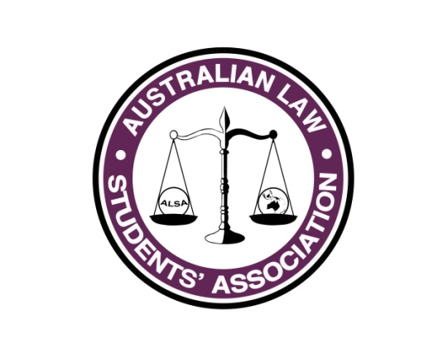
Sponsorship Report
Name: Andreena Kardamis
Position: Sponsorship Officer
E-mail: sponsorship@alsa.asn.au

What has happened so far...
In my role as Sponsorship Officer for the 2015/2016 term I have had three key areas of responsibility: Sponsorship, Communications and Public Interest Careers Fair.
Sponsorship
This term I re-designed and re-wrote the ALSA Prospectus to fit the new marketing image which was released in December 2015. This took 3 months and I was very happy with the result!
In 2016 ALSA lost 8 sponsors totalling $16,400 – in 2015 ALSA had 13 sponsors with total value of sponsorship being $43,000. This was a shock result as my conversations with sponsors at the start of my term indicated a keen willingness to continue sponsoring ALSA. Unfortunately from my last update from February council, ALSA emails had operational issues and as such this effected communication. Once emails went back online the sponsors who had previously indicated their willingness to continue sponsoring ALSA decided not to sponsor ALSA.
Despite the drop from 13 to 7 sponsors (I forged a new relationship with NSWYL), I am very happy to report an increase in sponsorship of $2,800 totalling $45,800. I believe that this represents that next year sponsorship will need to re-evaluate their strategy and focus on in-kind sponsorship agreements due to the climate of decreasing financial sponsorship.
Communications
This year I have led a National Communications Strategy. The team consisted of:
- Cass Page;
- Lachlan Robb;
- Alex Bell-Rowe;
- Kathryn Ellis;
- Grace Norris; and
- Lachlan Foster.
The aim of strategy was to ensure streamlined and concise communication with the ALSA committee, ALSA Conference team and stakeholders, with effect of stronger communication with Council. This was divided into 4 tiers, ALSA Council Communications, State Based Representative Meetings, Direct Law Students Communications and External Communications. Each tier had a number of outcomes that needed to be met. The main focus was Council and Conference communications, and I am pleased to report that these objectives have been met. Please see Appendix 1 to view the Communications Strategy.
Public Interest Careers Fair
This year I have been organising the ALSA & NSWYL Public Interest Careers Fair. This is a part of the sponsorship agreement between NSWYL and ALSA. The Fair will occur on Wednesday 3 August at the Law Society of NSW Building, from 4:30pm to 7:30pm. Currently 10 organisations have committed to attend and I hoping 10 more will join. I have contacted over 50 organisations, so I am hopeful for a positive outcome.

What do I think the future of Sponsorship will be like?
Sponsorship strategy needs to be redirected to in-kind sponsorship arrangements and the financial arrangements need to be re-packaged. The climate for financial agreements is decreasing. I will be in contact with the newly elected Sponsorship Officer to discuss this in detail.

Please contact me for any further questions.

Appendix 1
Australian Law Students’ Association (ALSA) Communications Strategy

Executive Summary

In 2016 ALSA presents the Communications Strategy. In order for ALSA to maintain its presence as the peak body for Law students across Australia, it is necessary to maintain effective communication with its stakeholders, in order to strengthen and add value to Council and Conference.

The aim of this strategy is to ensure that ALSA maintains direct contact and communication with Council and its affiliates, law students across Australia and the international legal community. Further, the objective is to raise awareness of ALSA’s work throughout the year, highlighting to its stakeholders what goals ALSA is achieving for, and on behalf of Law Students across Australia.

The modes of communication that were used in 2015 were Facebook, Twitter, email and newsletters via MailChimp. The Communications Strategy will provide detail as to what communications are being used and the reason for its use.

The ALSA Communications Strategy will consist of a four-tiered strategy of the following:
- ALSA Council Communications;
- State Based Representative Meetings;
- Direct Law Student Communications; and
- External Communications.

Each tier will work cohesively together to ensure that ALSA’s stakeholders are informed consistently with what ALSA is achieving throughout the year.

The Communications Strategy consists of a team from the ALSA Committee and will meet monthly to provide updates and discuss the progress of the strategy.
Communications Strategy Team
Team member | Team member role | Position on ALSA Committee
Andreena Kardamis | National Communications Coordinator | Director of Sponsorship
Cass Page | State Based Representative Officer & ALSA Council Officer 1 | Vice President of Administration
Lachlan Robb | ALSA Council Officer 2 | Director of Publications
Alex Bell-Rowe | Public Spokesperson | Vice President of Education
Kathryn Ellis | Conference Spokesperson | Conference 2016 Committee Representative
Grace Norris | Media & Marketing Officer | Director of Marketing
Lachlan Foster | IT Officer | Director of Information and Technology

The Communications Strategy Team will produce informative material that will outline ALSA & Conference and ALSA Resources. This material will then be provided to the State Based Representatives who will distribute it to the Law Student Societies in their respective states.

Additionally, the State Based Representative contacts are as follows:
- WA: Chris Burch
- SA: Michaela Olsson
- VIC: Cassandra Page
- TAS: Andrew Lonergan
- ACT: Albert Patajo
- NSW: Andreena Kardamis & Simon McNamara
- QLD: Lachlan Robb & Grace Norris

ALSA Council Communications

- 6 week marketing plan prior to Council to gain interest – Facebook event for Council AND utilise ALSA Knowledge Sharing Space – liaise with council conference convenor – National Communications Coordinator
- Ensure the Newsletter is being delivered and that people are viewing the Newsletter – ALSA Council Officer 1
- ALSA Council Officer 1 will ensure that material is being distributed to Council
- Review of the modes of communication that ALSA used in 2015. Was it effective? – ALSA Council Officer 1
- Use of new ALSA Website

State Based Representative Meetings

- ALSA President & ALSA VPA to introduce the ALSA Plan for 2015-16.
- State Based Representatives to disseminate information to attendees of the meetings and keep attendees updated on what ALSA is achieving.
- State Based Representatives should organise at least 4 meetings per year, can also act as knowledge sharing

Direct Law Student Communications
- ALSA Council Officer 1 will ensure that the State Based Representative are disseminating the information to the Law Student Societies
- Conference Spokesperson will provide monthly updates to Law Students about the progress of the Conference/add hype to Conference – should this be done through the Newsletter?
- Newsletter to update students on the monthly progress of ALSA, also deliver via Twitter. What is the best avenue for the Newsletter? MailChimp or something else?
- Use of new ALSA Website – IT Officer
- ALSA Council Officer to maintain contact with stakeholders via social media (every few weeks or so post a funny status?)
- 6 week marketing plan for Conference? Liaise with Conference Spokesperson to understand what social media conference plan is?

External Communications
- ALSA President and National Communications Coordinator will contact and develop relationships with other Law Societies internationally with the aim of collaboration and learning
- Develop relationship with NSWYL and NSWLS
- Make contact with other Law Societies around Australia to establish a relationship
- Public Spokesperson to be the ‘face’ of ALSA in all public announce

