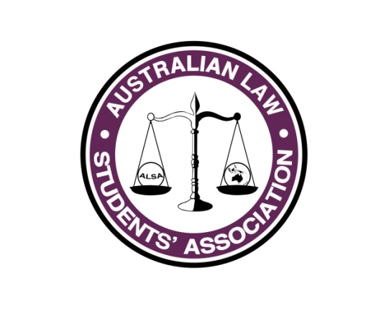
Marketing Report
Name: Grace Norris
Position: Marketing Officer
E-mail: marketing@alsa.asn.au

What has happened so far...
So far, we have had the incredibly successful Facebook marketing campaign of 10/10 week. Views were incredibly high, with shares going through the roof which only worked to increase our reach. As well as this, I have implemented a new way to engage with readers, by ending some posts with questions. This has worked a treat, and our fans are now commenting on our posts with their ideas and opinions.

What you plan to do between now and July Conference
I hope to implement a share for share system with our sponsors and other Facebook pages that will mutually benefit both pages by increasing the reach of key posts. This will work by our page agreeing to share another page’s post, while they share one of ours in return, resulting in more relevant people seeing the post, and also a link to the page, which will result in more ‘likes’. In this time, there will also be two newsletter released. As well as this, there will be flyers developed for O-week that highlight the importance of ALSA to be distributed during O-Week.

