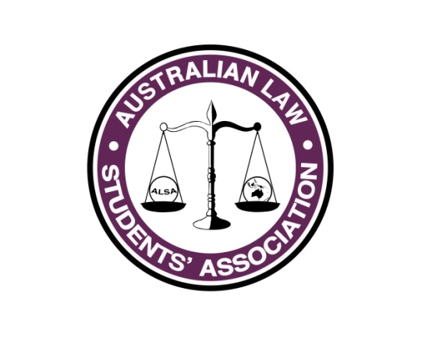
President’s Report
Name: Paul Melican
Position: President
E-mail: president@alsa.asn.au

Report on Motions from Sep-15 SGM
Motion to change the dates for ALSA Councils
Refer constitutional amendment AMD01.

Dan’s Motion – to change the notice period for Constitutional Amendments
My reading of s249H and s249L Corporations Act 2001 (CTH) would be that we must have 21 days notice for all Constitutional Amendments so as I said in Sep-15 Council we are legally stuck with this notice period.
No further action taken.

Motion for State Based ALSA’s
Setup in all states and territories (except Tasmania and NT for obvious reasons) ALSA State based contacts as follows;
Queensland: Lachlan Robb & Grace Norris, an ALSA planning meeting has already occurred
NSW: The pre-existing NSWYL Committee for Presidents essentially serves the same function as the proposed ALSA State meetings so Andreena Kardamis is attending these as the ALSA Rep.
Victoria: In 2015 a Victorian Presidents Committee was formed, ALSA attends as a nonvoting member, Paul Melican & Cass Page are the ALSA Reps.
SA: Michaela Olson is the state representative and has been in touch with LSS/A’s
Tasmania: No meeting, as there is only one LSS/A in Tasmania, Andrew Lonergan is the ALSA Rep.
NT: No meeting, as there is only one LSS/A in NT, Paul Melican is the ALSA Rep.
WA: Chris Burch is the ALSA representative who has been in contact with all LSS/A’s

What has happened so far...?
We have all been busy working away at preparation for Feb-16 Council, advocacy and planning for 2016. As all of what I do is covered in other portfolios I shall not restate is covered elsewhere so at a high level;
- 2016 Plan
- State based LSS/A’s
- Commenced Knowledge sharing forums
- Sponsorships look like they are going to have a great year
- Appointed Risk & Policy Officers
- Feb-16 Council
- Made contact with our international partners in NZ LSA, AsiaLSA, and Europe LSA (Czech Republic).
- I have written two articles that have been published by Lawyers weekly.
  - One on why year 12 students should consider law
  - And the other on the benefits of doing Paralegal work whilst studying

What you plan to do between now and July Conference
Most of what we have is covered off in the Plan that I hope you have all seen, a few specific initiatives that I would like to pursue are;
- Trying to work out how many law students there are that are studying out of state, and what we might be able to do to engage with them
- Push the advocacy agenda, attempt to meet with federal MP’s around Educational and Tax issues and generate more discussion by getting more articles published.
- Article for the Australian Law Journal
- Complete overhaul of the ALSA By-laws so they make sense with our newly appointed Policy Officer
- Final bits around closing down the old incorporated association
- Push for more GD activities as Conference
- Formalise the risk process and action the outstanding items from the risk review conducted last year with our newly appointed risk officer

